HISTORICAL EVENT FILTER WITH DATE AND TIME FILTER APPLIED

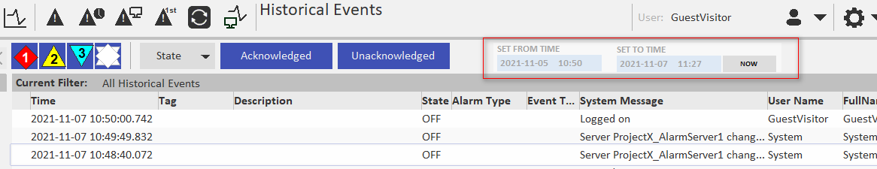
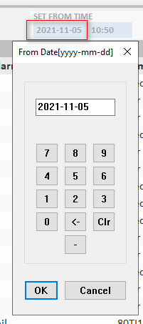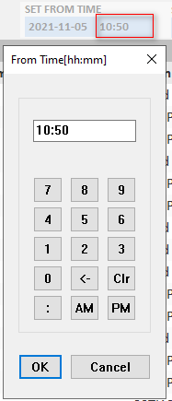
Local Tag created to store Date & Time picker.
L_SOE_FilterToDate [Data Type = STRING]
L_SOE_FilterToTime [Data Type = STRING]
L_SOE_FilterFromDate [Data Type = STRING]
L_SOE_FilterFromTime [Data Type = STRING]

Now button will set “To Time” to “Now” (both date and time).
The custom script below will append date & time filter to current filter applied.
This is done by adding a tie in to SA Include-> AlarmPage.ci-> FUNCTION _AlarmPage_UpdateFilter().
*******************************************************************************************
FUNCTION _AlarmPage_UpdateFilter()

INT nAlarmListAn = DspGetAnFromName("AlarmList");
INT nError;
INT hFilter;

// Reset the alarm list scroll position to 0
_ArrayView_SetYOffset(nAlarmListAn, 0);

// Explicitly include system events if it is SoE and filter is specified
STRING sFilterGroup = AlarmPage_GetFilterGroup("FltrGrp");
INT bForceSystemEvents = FALSE;
INT nType = PageGetInt("__Type");

IF (nType = 15 OR nType = 16) THEN
bForceSystemEvents = FilterGroup_GetItemCount(sFilterGroup) > 0;

END

hFilter = AlarmFilterEditOpen(nAlarmListAn);
IF hFilter <> BAD_HANDLE THEN
// Inject opening query clause for explicitly including system events
IF (bForceSystemEvents) THEN
nError = AlarmFilterEditSet(hFilter, "(");
ELSE
nError = AlarmFilterEditSet(hFilter, "");
END

IF nError = 0 THEN
// Process all filters
AlarmFilter_AppendFilterGroup(hFilter, sFilterGroup);

// Inject closing query clause for explicitly including system events
IF (bForceSystemEvents) THEN
//AlarmFilterEditAppend(hFilter, ") OR StateNumeric=0");//default
AlarmFilterEditAppend(hFilter, ")");
END

nError = AlarmFilterEditCommit(hFilter);
END

AlarmFilterEditClose(hFilter);
END

_AlarmPage_UpdateFilterText(_AlarmPage_GetCurrentFilter());

//********************************************************************************************
//*******VICOSOL TIE-IN TO BE ABLE TO SORT EVENT LIST ON DATE&TIME****************************
//********************************************************************************************
//
VIC_AlarmPage_UpdateSOE();
//
//********************************************************************************************
//********************************************************************************************

END

//-----------------------------------------------------------------------------------------------

*******************************************************************************************
Custom script to append date and time filters

/////////////////////////////////////////////////////////////////////////////////////////////////////////////////////////////////
// VICOSOL AS
//FUNCTION NAME: VIC_SOEFilterInit()
//REVISION: 01
//DESCRIPTION: Historical Event List: This function is used to set initial values when Historical Event screen is opened.
//DATE OF REVISION: 2021-10-06
//REVISED BY: Rune Johannessen
//REVISION DESCRIPTION: INITIAL GENERATION
//
//ADDITONAL DESCRIPTION: This function is called from Historical Event screen on page entry.
// Page Properties - Events - On Page Entry
//
// Upon initialization End date and time is set to current time and Start date and time is set to current time.
//
//
//
//
//
//
// SPECIAL NOTE:
//
// ________________________________________________
// ©Vicosol AS All rights reserved
/////////////////////////////////////////////////////////////////////////////////////////////////////////////////////////////////

FUNCTION VIC_SOEFilterInit()
INT TimeSpan;
STRING FromDate;
STRING FromTime;
STRING ToDate;
STRING ToTime;

//Initial timespan is set here. Enter time span i seconds from end date and time.
//Example:
//Setting Timespan to 86400 (24hr) will set the start date to "yesterday" with same time as current.
//
TimeSpan = 86400;
//
//Upon initialization End date and time is set to current time
ToDate = Date();
ToTime =Time();
//Upon initialization Start date and time is set to current time - TimeSpan
FromDate = TimeToStr(DateSub(StrToDate(ToDate),TimeSpan),2);
FromTime = Time();

//Function output values
L_SOE_FilterToDate = ToDate;
L_SOE_FilterToTime = ToTime;
L_SOE_FilterFromDate = FromDate;
L_SOE_FilterFromTime = FromTime;

END
//-----------------------------------------------------------------------------------------------

/////////////////////////////////////////////////////////////////////////////////////////////////////////////////////////////////
// VICOSOL AS
//FUNCTION NAME: VIC_SOETime_Now()
//REVISION: 01
//DESCRIPTION: Historical Event List: This function will set "To Time" to Now.
//DATE OF REVISION: 2021-10-06
//REVISED BY: Rune Johannessen
//REVISION DESCRIPTION: INITIAL GENERATION
//
//ADDITONAL DESCRIPTION: This function is called from button on SOE page
//
//
//
//
//
//
//
//
// SPECIAL NOTE:
//
// ________________________________________________
// ©Vicosol AS All rights reserved
/////////////////////////////////////////////////////////////////////////////////////////////////////////////////////////////////

FUNCTION VIC_SOETime_Now()

STRING ToDate;
STRING ToTime;

ToDate = Date();
ToTime =Time();

//Function output values
L_SOE_FilterToDate = ToDate;
L_SOE_FilterToTime = ToTime;
END
//-----------------------------------------------------------------------------------------------

/////////////////////////////////////////////////////////////////////////////////////////////////////////////////////////////////
// VICOSOL AS
//FUNCTION NAME: VIC_AlarmPage_UpdateSOE()
//REVISION: 01
//DESCRIPTION: Historical Event List: This function will take current SOE filter and append Date&Time filter.
//DATE OF REVISION: 2021-10-06
//REVISED BY: Rune Johannessen
//REVISION DESCRIPTION: INITIAL GENERATION
//
//ADDITONAL DESCRIPTION: This function is called from SA Include-> AlarmPage.ci-> FUNCTION _AlarmPage_UpdateFilter()
//
//
//
//
//
//
//
//
// SPECIAL NOTE:
// The tie-in to SA Include must be manually updated if new version AVEVA Plant Scada is installed.
// ________________________________________________
// ©Vicosol AS All rights reserved
/////////////////////////////////////////////////////////////////////////////////////////////////////////////////////////////////

FUNCTION VIC_AlarmPage_UpdateSOE()

INT nSOEAn = DspGetAnFromName("AlarmList");
IF (nSOEAn < 1) THEN
RETURN;
END

INT hFilter;
INT nError = 0;

INT FromTime;
INT ToTime;

FromTime = DateAdd(StrToDate(L_SOE_FilterFromDate),StrToTime(L_SOE_FilterFromTime)); //Converts Start Date and Time to Integer value
ToTime = DateAdd(StrToDate(L_SOE_FilterToDate),StrToTime(L_SOE_FilterToTime)); //Converts End Date and Time to Integer value

hFilter = AlarmFilterEditOpen(nSOEAn);
IF hFilter <> BAD_HANDLE THEN

IF nError = 0 THEN

AlarmFilterEditAppend(hFilter,";");
AlarmFilterEditAppend(hFilter, "TAG=*" + ";TIME>" + IntToStr(FromTime) +";TIME<" + IntToStr(ToTime)); // The ";" between <filter_expr> is interpreted as AND
nError = AlarmFilterEditCommit(hFilter);

END
AlarmFilterEditClose(hFilter);
END
END

//-----------------------------------------------------------------------------------------------

