Customer Requirement
Our customers require the ability to maintain complete Timeseries historical trends (collect samples), including timestamped samples polled after a PLC communication loss (outage could be for several hours/days). The customer is using DNP PLCs which can store up to 100,000 timestamped events. If communications to the PLC are lost, the PLC continues to buffer the change events (timestamped value changes). We need to be able to collect all the buffered events when communications are restored to the PLC, and view in a Timeseries trend.
Problem Descriptions
Some of our customers have unreliable communication paths to the PLCs in field. The communication paths can be over the customer WAN, master radios, terminal servers, direct ethernet, or some combination. As a result, they like to use PLCs that can buffer events while communications are out to the main SCADA system.
Problem #1: Collection of samples older than the latest sample in collect table
The DNP protocol supports the polling of timestamped events and works as expected. It even has parameters that can help poll the timestamped events in such a way as to not interfere with regular polling, and throttle the amounts, etc. The first problem we encountered is within the baseline collection module. At the top of each hour (TOH), a sample is written to the Timeseries collect table, for each point on collect. This sample is written whether the connection to the PLC is offline or online (verified by selecting from Timeseries..collect while PLC was disconnected). It is this TOH record that prevents any other samples with an older timestamp, from being written to the collect table. So, if the communication outage happens within an hour period, the samples are collected, and everything is fine. However, if the communication outage crosses an hour boundary (in most cases it does), all samples with a timestamp older than the most recent TOH, will be rejected (not inserted into collect table).
Note – The baseline Enterprise SCADA system used for testing had the "FIELDTIME_AS_TIME_IN_COLLECT: true” set to true.
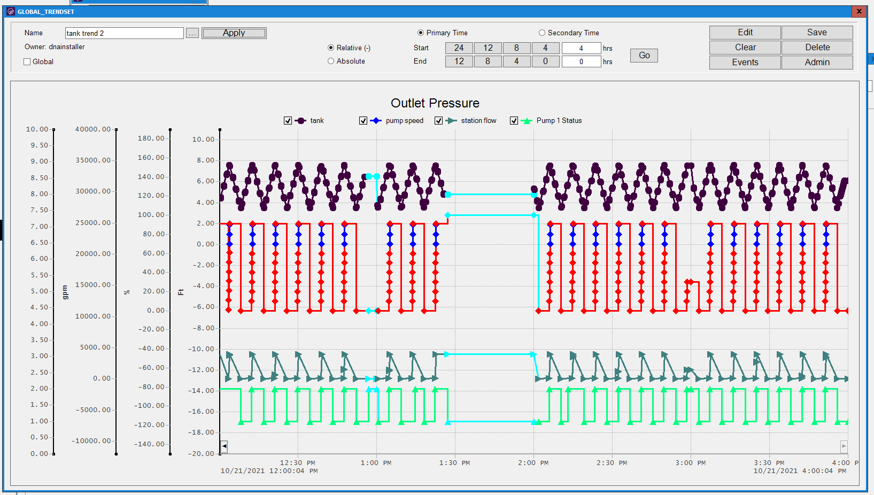
Figure 1 Enterprise SCADA baseline trend w/outage

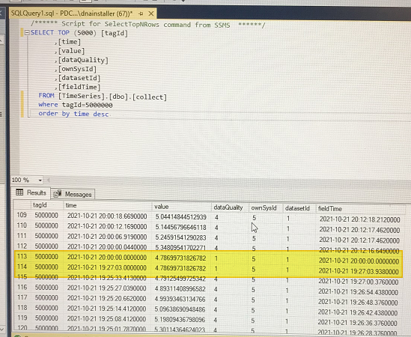
Figure 2: Collect rows with TOH 20:00:00

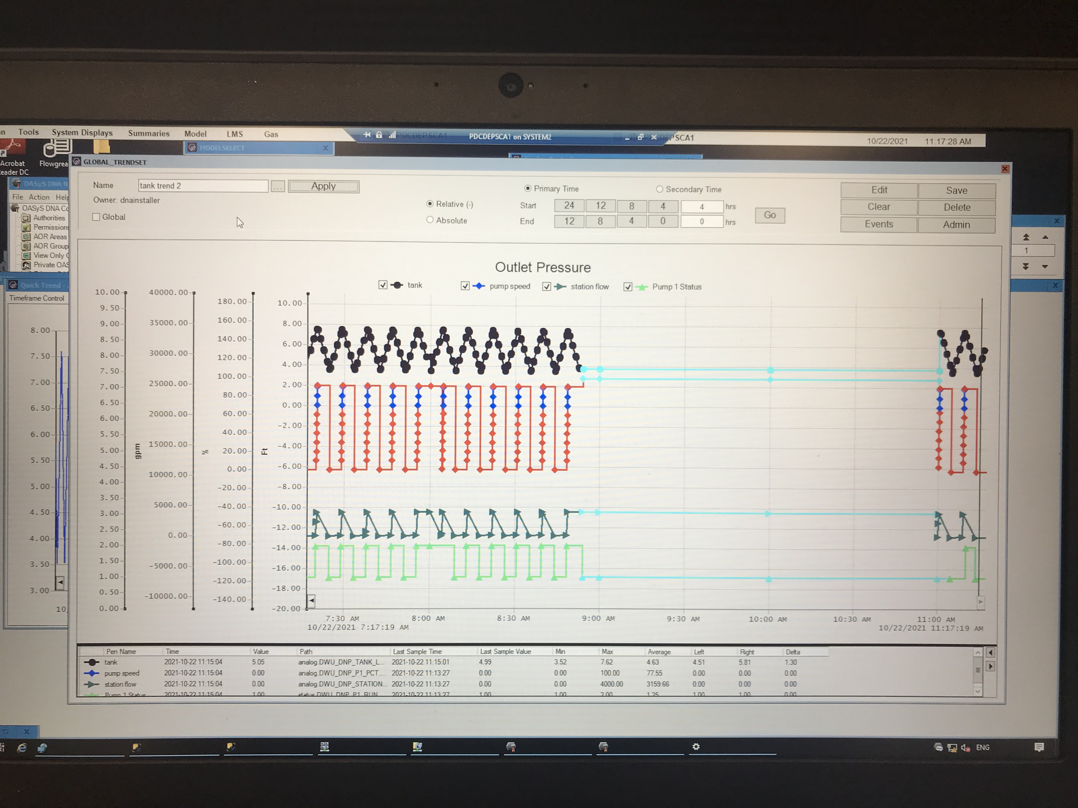
Figure 3: Baseline trend with outage over 3-hour boundaries

Possible solutions:
Currently, our solution to work around the TOH problem is to add a new collect type (called isHistorical). Any collect points that belong to a PLC with event uploads, are configured to have this custom collect type. The baseline collect module is then modified to look for this new type and skip the TOH processing for any of these points. The result is that during a comm outage, no records are written to Timeseries collect. Only when the PLC comes back online, and the protocol polls the values (events before current poll), records are written to Timeseries collect.

Problem #2: Collectxfer does not keep up, RealTime collect buffer overflows
During the Historical upload, the rate at which the samples are brought in by the protocol driver is faster than the rate in which collectxfer sends the RealTime 200-sample collect buffer contents out to Historical. Once the RealTime buffer has 200 samples, any new incoming samples are dropped, leaving random holes in the data.

Possible solutions:
Detect when a sample will be dropped by modifying the collect code in the place where it inserts the sample to the RealTime buffer. If the RealTime buffer is full, instead of just dropping the sample, spool the sample into a custom Historical “collect overflow” table using “spoolTransaction”. Run another background process which checks the collect overflow table every x seconds, and if it finds any records, insert them into collect using the updateCollect API calls. We implemented this solution for one customer, and it works, although very inefficient.

