PRODUCT: | Plant SCADA
CATEGORIES: | Usability
MARKET: | All
PROBLEM OR NEED TO SOLVE: | Static maps in Plant SCADA Studio for instance used for enumerations
EXPECTED FUNCTIONALITY: | See next pages
RATING | 8
BUSINESS CASE
REQUESTOR(S) | Site ID:85563  Site Name : Rijkswaterstaat Heinenoordtunnel
If known, mentioned related existing enhancement requests.
(To be entered by Tech Support Engineer)

Static Maps in Plant SCADA Studio
Projects often have the need for enumerations. Variable Tag values represent for instance a state. Especially in tunnel projects there are a lot of different enumerations. Currently you who have to script all these enumerations in Cicode and create maps on startup in runtime. It would make things easier if you could define these maps in the Plant SCADA Studio instead of scripting this. Here’s an example of how this could work:

Define a map
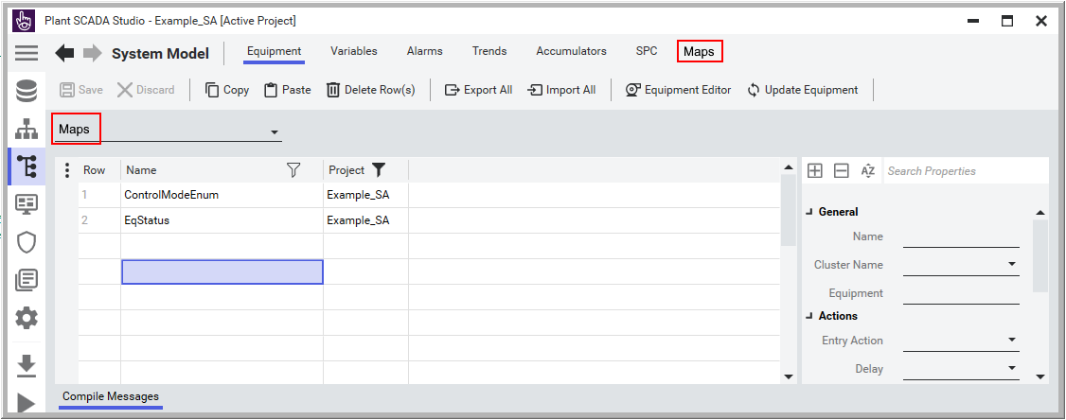

Define the keys and values of each map
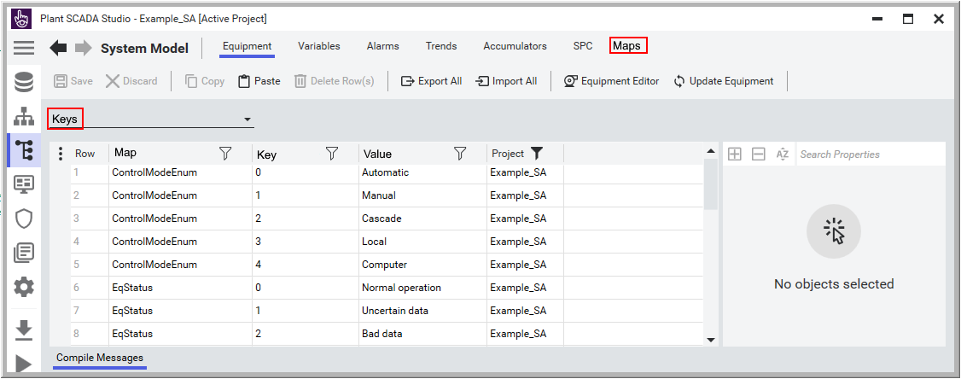

For a variable tag add another field in which you can define the map:
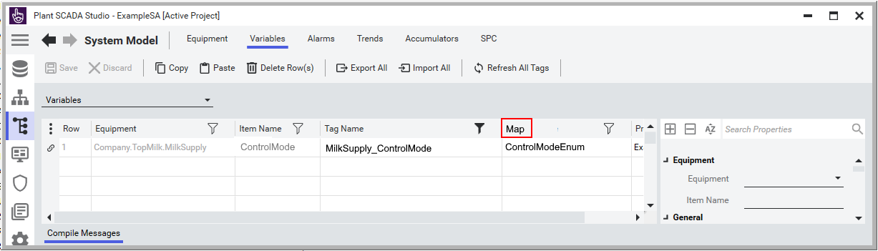

Compiler:
- Check if mapname is unique
- Check if mapnames and all keys don’t contain spaces
- Check if map defined at Variable Tag exists
- Check if all keys of one map are unique
- Write all maps, keys and values into the _maps.rdb

At startup runtime:
- Open the _maps.rdb
- Create all defined maps
- Add all keys and values into the maps
In runtime it can look like (in this case wrapped in a combobox):
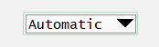

Cicode:
Modify:
- TagGetProperty() and AssGetProperty() functions, add a Property with name Map which returns the name of the defined map.
- TagInfo (), TagInfoEx(), AssInfo (), AssInfoEx() functions, add a Type which returns the name of the defined map.
Add:
- SubscriptionGetMap(iHandle, sOffset ), which returns the value from the map
Create a new function which returns the value from the map based on the value of the tag, something like:
STRING
FUNCTION
GetMapValue(STRING sTag, INT iKeyName)

STRING sMap;
STRING sReturn;
STRING sKeyName;

sMap = TagGetProperty(sTag, ”Map”);
IF sMap <> “” THEN
IF MapExists(sMap) THEN
sKeyName = IntToStr(iKeyName);
IF MapKeyExists(sMap, sKeyName) THEN
sReturn = MapValueGet(sMap, sKeyName);
ELSE
sReturn = “ERROR : “ + sKeyName + “ doesn’t exist in map” + sMap;
END
ELSE
sReturn = “ERROR : “ + sMap + “ doesn’t exist”;
END
ELSE
sReturn = “ERROR : No Map defined for tag : “ + sTag;
END
RETURN sReturn;
END

PUBLIC
INT
FUNCTION
AddMapsOnStartup()

STRING sMap, sKey, sValue;
INT hRDB;
INT iReturn;

hRDB = RdbOpen("_Maps");
IF (hRDB <> -1) THEN
miError = RdbFirstRec(hRDB);
WHILE (miError <> -1) DO
sMap = RdbGet(hRDB, "Map");
sKey = RdbGet(hRDB, "Key");
sValue = RdbGet(hRDB, "Value");
iReturn = iReturn + _AddMapKeyValue(sMap, sKey, sValue);
miError = RdbNextRec(hRDB);
SleepMS(0);
END
RdbClose(hRDB);
ELSE
iReturn = -1;
END
RETURN iReturn;
END

PRIVATE
FUNCTION
_AddMapKeyValue(STRING sMap, STRING sKey, STRING sValue)

INT iReturn = -1;

IF sMap <> “” AND sKey <> “” AND sValue <> “” THEN
sMap = MapOpen(sMap, 2);
iReturn = MapValueSet(sMap, sKey, sValue, 2)
END
RETURN iReturn
END

To be able to show a dropdrown menu like this:
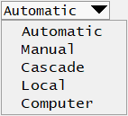

The following Cicode can be used

PUBLIC
INT
FUNCTION
ShowMapMenu(STRING sTag, STRING sFont = "")

INT nX;
INT nY;
INT iSelection;
INT nAN = KeyGetCursor();
INT nValue;
INT nMenuID = 1;
INT iReturn = -2;
STRING sMap;
STRING sKey;
STRING sMenuValueLookupMap;

ErrSet(1);

IF StrToInt(UserInfo(0)) = 1 THEN
IF sTag <> "" THEN
sMap = TagGetProperty(sTag, ”Map”);
sMenuValueLookupMap = MapOpen("", 0);
sKey = MapKeyFirst(sMap);
WHILE(sKey <> "") DO
DspPopupMenu(0, MapValueGet(sMap, sKey));
MapValueSet(sMenuValueLookupMap, nMenuID, sKey);
sKey = MapKeyNext(sMap, sKey);
nMenuID = nMenuID + 1;
END
nX = DspGetAnLeft(nAN);
nY = DspGetAnBottom(nAN);
iSelection = _ShowMapMenu("", nX, NY, TRUE, TRUE, sFont);
IF iSelection > 0 THEN
nValue = MapValueGet(sMenuValueLookupMap, iSelection);
iReturn = TagWrite(sTag, nValue, 0, 1);
END
MapClose(sMenuValueLookupMap);
END
ELSE
iReturn = -1;
END
ErrSet(0);
RETURN iReturn;
END

PRIVATE
INT
FUNCTION
_ShowMapMenu(STRING sData = "", INT iXPos = -1, INT iYPos = -1, INT bScaleX = TRUE, INT bScaleY = TRUE, STRING sFont = "")

INT nTime;
INT nWindow;
INT nSelection;
INT iReturn;

nTime = TimeCurrent();
nWindow = WinNumber();
iReturn = PageSetInt(mcsPopupMenuTimestamp, nTime, nWindow);
IF iReturn = 0 THEN
iReturn = _MapSetFont(sFont);
nSelection = DspPopupMenu(-1, sData, iXPos, iYPos, bScaleX, bScaleY);
END

IF (WinNumber() <> nWindow) THEN
nSelection = -1;
ELSE
IF (PageGetInt(mcsPopupMenuTimestamp, nWindow) <> nTime) THEN
nSelection = -1;
END
END
RETURN nSelection;
END

PRIVATE
INT
FUNCTION
_MapSetFont(STRING sFont)

INT hFont;
INT iReturn = -1;

IF sFont = "" THEN
hFont = DspFontHnd(GetFontMultiRes(WndMonitorIsUHD4K(), "SA_Menu"));
ELSE
hFont = DspFontHnd(sFont);
END

IF (hFont <> -1) THEN
DspSetPopupMenuFont(hFont);
iReturn = 0;
END
RETURN iReturn;
END

AVEVA Plant SCADA Historian connector
Add the map defined at the Variable Tag into the Historian configuration. Import all the maps into the Historian configuration. The value of a tag in the Historian configuration can be translated into the value defined in the map.

