Greetings!
As for when we would want this… it would not necessarily be for 2021 SP2. We are already planning an upgrade for approximately 2026 and looking to go onto the latest software at that time. If this is a large or invasive activity we would consider waiting for the newer version release.
The use-case is:
We want to create a 2-bit status point that has a base message of to reflect the open/close or travel state of the valve, that has input from 2 separate RTU signals (one indicating closed and one indicating open).
We are currently using:
For the output, we want to configure output to 2 different RTU signals to send the command to open or close.
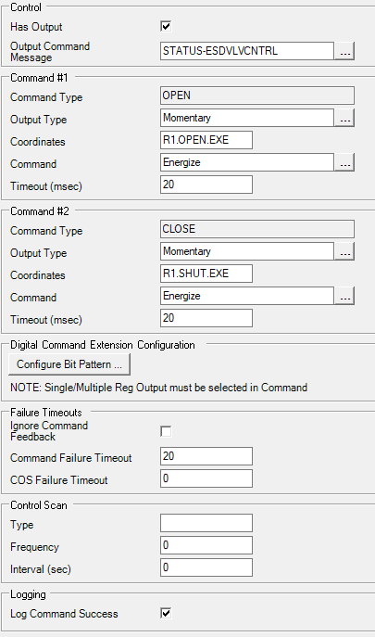
Using the message definition:
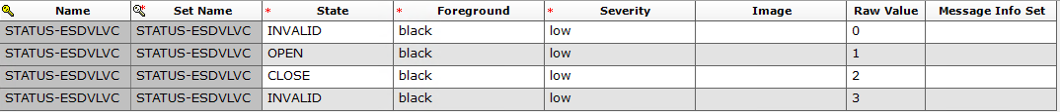
Finally, an abnormal state will be defined for when the valve feedback indicates closed.
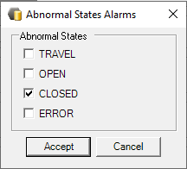

Then, whenever configured to alarm on the state even when commanded and the valve closed (commanded or uncommanded) we would want an alarm. The message could just say commanded instead of uncommanded state change.

As supporting info… we get the uncommanded state change alarm for this valve commanded shut if we experience a comm outage 5 minutes later.

